# Properties of Array in C

An array in C is a fixed-size homogeneous collection of elements stored at a contiguous memory location. It is a derived data type in C that can store elements of different data types such as int, char, struct, etc. It is one of the most popular data types widely used by programmers to solve different problems not only in C but also in other languages.

The properties of the arrays depend on the programming language. In this article, we will study the different properties of Array in the C programming language.

1. Fixed Size Collection

2. Homogeneous Elements

3. Indexing in Array

4. Dimensions of Array

5. Contiguous Storage

6. Random Access

7. Array name relation with pointer

8. Bound Checking

9. Array Decay

## C Array Properties

### 1. Fixed Size of an Array

In C, the size of an array is fixed after its declaration. It should be known at the compile time and it cannot be modified later in the program. The below example demonstrates the fixed-size property of the array.

**Example:**

**// C Program to Illustrate the Fixed Size Properties of the**

**// Array**

**#include <stdio.h>**

**int main()**

**{**

**// creating a new array of size 5**

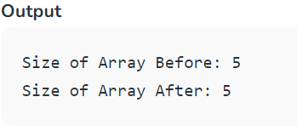 **int array[5] = { 1, 2, 3, 4, 5 };**

**printf("Size of Array Before: %d\n",**

**sizeof(array) / sizeof(int));**

**// trying to increase the size of the array**

**array[6];**

**// not checking the size**

**printf("Size of Array After: %d",**

**sizeof(array) / sizeof(int));**

**return 0;**

**}**

**2. Homogeneous Collection**

An array in C cannot have elements of different data types. All the elements are of the same type.

**Example:**

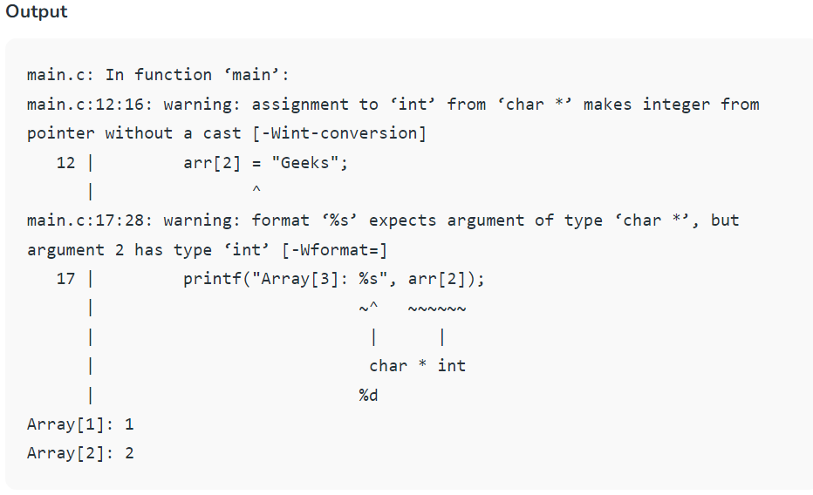**// C program to Demonstrate the Homogeneous Property of the C Array**

**#include <stdio.h>**

**int main()**

**{**

**// declaring integer array**

**int arr[3] = { 1, 2 };**

**// trying to store string in the third element**

**arr[2] = "Geeks";**

**// printing elements**

**printf("Array[1]: %d\n", arr[0]);**

**printf("Array[2]: %d\n", arr[1]);**

**printf("Array[3]: %s", arr[2]);**

**return 0;**

**}**

1. **Indexing in an Array**

Indexing of elements in an Array in C starts with 0 instead of 1. It means that the index of the first element will be 0 and the last element will be (size – 1) where size is the size of the array.

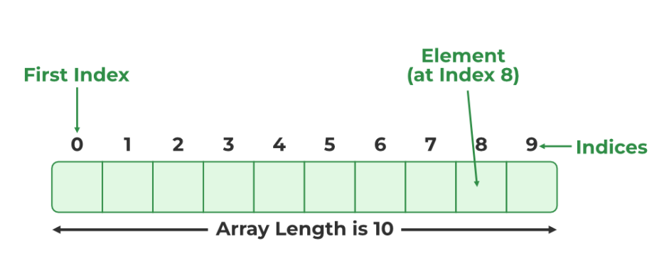

**Example:**

// C Program to Illustrate Array Indexing in C

#include <stdio.h>

int main()

{

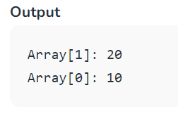 // creating integer array with 2 elements

int arr[2] = { 10, 20 };

// printing element at index 1

printf("Array[1]: %d\n", arr[1]);

// printing element at index 0

printf("Array[0]: %d", arr[0]);

return 0;

}

1. **Dimensions of the Array**

An array in C can be a single dimensional like a 1-D array or multidimensional like a 2-D array, 3-D array, and so on. It can have any number of dimensions. The number of elements in a multidimensional array is the product of the size of all the dimensions.

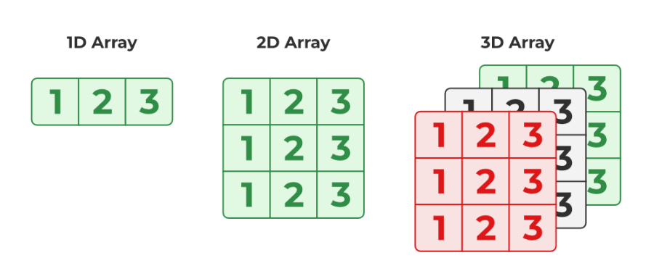

**Example:**

**// C Program to create multidimensional array**

**#include <stdio.h>**

**int main()**

**{**

**// creating 2d array**

**int arr2d[2][2] = { 1, 2, 3, 4 };**

**// creating 3d array**

**int arr3d[2][2][2] = { 1, 2, 3, 4, 5, 6, 7, 8 };**

**printf("2D Array: ");**

**// printing 2d array**

**for (int i = 0; i < 2; i++) {**

**for (int j = 0; j < 2; j++) {**

**printf("%d ", arr2d[i][j]);**

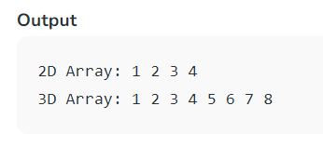 **}**

**}**

**printf("\n3D Array: ");**

**// printing 3d array**

**for (int i = 0; i < 2; i++) {**

**for (int j = 0; j < 2; j++) {**

**for (int k = 0; k < 2; k++) {**

**printf("%d ", arr3d[i][j][k]);**

**}**

**}**

**}**

**return 0;**

**}**

1. **Contiguous Storage**

All the elements in an array are stored at contiguous or consecutive memory locations. We can easily imagine this concept in the case of a 1-D array but multidimensional arrays are also stored contiguously. It is possible by storing them in row-major or column-major order where the row after row or column after the column is stored in the memory. We can verify this property by using pointers.

**Example:**

**// C Program to Verify the Contiguous Storage of Elements in**

**// an Array**

**#include <stdio.h>**

**int main()**

**{**

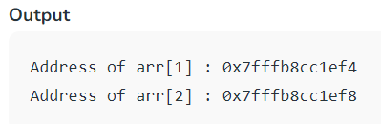

**// creating an array of 5 elements**

**int arr[5] = { 1, 2, 3, 4, 5 };**

**// defining pointers to 2 consecutive elements**

**int* ptr1 = &arr[1];**

**int* ptr2 = &arr[2];**

**// printing the address of arr[1] and arr[2]**

**printf("Address of arr[1] : %p\n", ptr1);**

**printf("Address of arr[2] : %p", ptr2);**

**return 0;**

**}**

In the above example, the difference between the addresses of arr[1] and arr[2] is 4 bytes which is the memory required to store a single integer. So, at memory addresses 0x7ffebc02e054 to 0x7ffebc02e057, arr[1] is stored and in the next 4 bytes, arr[2] is stored. The same is true for all the elements.

**6. Random Access to the Elements**

It is one of the defining properties of an Array in C. It means that we can randomly access any element in the array without touching any other element using its index. This property is the result of Contiguous Storage as a compiler deduces the address of the element at the given index by using the address of the first element and the index number.

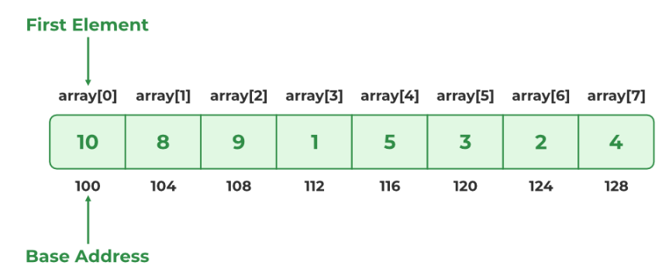

**Example:**

// C Program to check the random access property of the

// array

#include <stdio.h>

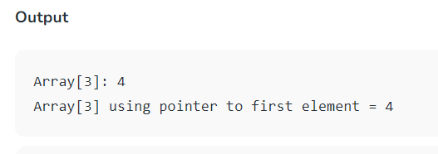int main()

{

// creating an array of 5 elements

int arr[5] = { 1, 2, 3, 4, 5 };

// address of first element

int* ptr = &arr[0];

// printing arr[3]

printf("Array[3]: %d\n", arr[3]);

// printing element at index 3 using ptr

printf("Array[3] using pointer to first element = %d",

*(ptr + 3));

return 0;

}

**7. Relationship between Array and Pointers**

Arrays are closely related to pointers in the sense that we can do almost all the operations possible on an array using pointers. The array’s name itself is the pointer to its first element.

**Example:**

// C Program to Illustrate the Relationship Between Array

// and Pointers

#include <stdio.h>

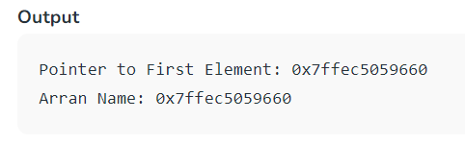int main()

{

// creating an array with 3 elements

int arr[3] = { 1, 2, 3 };

int* ptr = &arr[0];

// Pointer to first element

printf("Pointer to First Element: %p\n", ptr);

// Array name as pointer

printf("Arran Name: %p", arr);

return 0;

}

**8. Bound Checking**

Bound checking is the process in which it is checked whether the referenced element is present within the declared range of the Array. In C language, array bound checking is not performed so we can refer to the elements outside the declared range of the array leading to unexpected errors.

Example:

// C Program to Illustrate the Out of Bound access in arrays

#include <stdio.h>

int main()

{

// creating new array with 3 elements

int arr[3] = { 1, 2, 3 };

// trying to access out of bound element

printf("Some Garbage Value: %d", arr[5]);

return 0;

}

As seen in the above example, there is no error shown by the compiler while accessing memory that is out

of array bounds.

1. **Array Decay**

Array decay is the process in which an array in C loses its dimension in certain conditions and decays into pointers. After this, we cannot determine the size of the array using sizeof() operator. It happens when an array is passed as a pointer.

Example:

// C Program to Demonstrate the Array Decay

#include <stdio.h>

// function

void func(int* arr)

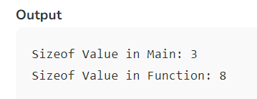{

printf("Sizeof Value in Function: %d", sizeof(arr));

}

int main()

{

// creating array with 3 elements

char arr[3];

printf("Sizeof Value in Main: %d\n", sizeof(arr));

// passing array

func(arr);

return 0;

}

The size of the array in the main() is 3 bytes which is the actual size of the array but when we check the size of the array in func(), the size comes out to be 8 bytes which instead of being the size of the array, it is the size of the pointer to the first element of the array.

**“malloc function”**

malloc (short for "memory allocation") is a standard library function in C that is used for dynamic memory allocation. It allows you to request a block of memory from the heap at runtime, and it returns a pointer to the first byte of that allocated memory. Here's an explanation of how malloc works in C:

Including the Necessary Header File: To use malloc, you need to include the ***<stdlib.h>*** header file at the beginning of your C program:

Syntax : **void* malloc(size_t size);**

**size** is the number of bytes you want to allocate.

**malloc** returns a void* pointer, which is a generic pointer to the allocated memory block. It's a pointer of type void, which means it doesn't have a specific data type.

Example : **int* intArray = (int*)malloc(10 * sizeof(int));**

**malloc(10 * sizeof(int)):** It calls the malloc function to allocate a block of memory on the heap. In this case, it's requesting memory to store an array of 10 integers. **10 * sizeof(int)** calculates the total number of bytes needed for this array, where **sizeof(int)** represents the size of an integer in bytes on your system. The result of this malloc call is a pointer to the first byte of the allocated memory block.

**(int*):** This part of the code is a type cast. It converts the pointer returned by malloc (which has the type **void\***) to a pointer of type **int\***. This casting is necessary because malloc returns a generic pointer, and you need to specify the data type of the elements that will be stored in the allocated memory. By casting it to **int\***, you are telling the compiler that this memory will be used to store integers.

**int* intArray:** This part declares a pointer variable named intArray with the type **int\***. It will be used to store the address of the memory block allocated by malloc.